**Multiple Provider Configurations**

**Step-01: Introduction**

* Understand and Implement Multiple Provider Configurations

**Step-02: How to define multiple provider configuration of same Provider?**

* Understand about default provider
* Understand and define multiple provider configurations of same provider

Terraform.tf file

# Provider-1 for us-east-1 (Default Provider)

provider "aws" {

region = "us-east-1"

profile = "default"

}

# Provider-2 for us-west-1

provider "aws" {

region = "us-west-1"

profile = "default"

alias = "aws-west-1"

}

us-east-1.tf

# Resource Block to Create VPC in us-east-1 which uses default provider

resource "aws_vpc" "vpc-us-east-1" {

  cidr_block = "10.1.0.0/16"

  tags = {

    "Name" = "vpc-us-east-1"

  }

}

us-west-1.tf

**Step-03: How to reference the non-default provider configuration in a resource?**

# Resource Block to Create VPC in us-west-1

resource "aws_vpc" "vpc-us-west-1" {

cidr_block = "10.2.0.0/16"

#<PROVIDER NAME>.<ALIAS>

provider = aws.aws-west-1

tags = {

"Name" = "vpc-us-west-1"

}

}

**Step-04: Execute Terraform Commands**

# Initialize Terraform

terraform init

# Validate Terraform Configuration Files

terraform validate

# Generate Terraform Plan

terraform plan

# Create Resources

terraform apply -auto-approve

# Verify the same

* 1. Verify the VPC created in us-east-1

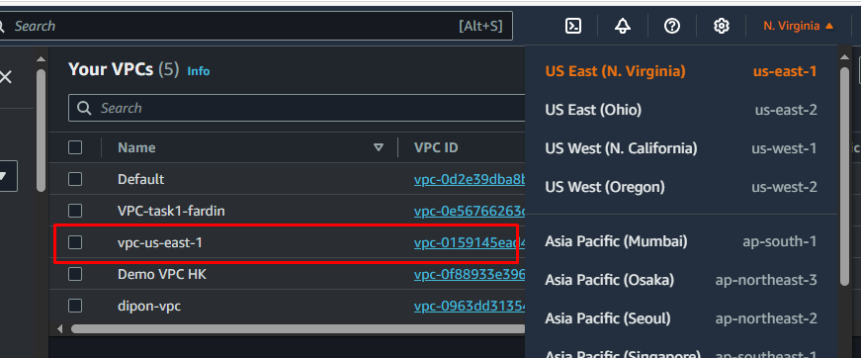

* 1. Verify the VPC created in us-west-2

**Step-05: Clean-Up**

# Destroy Terraform Resources

terraform destroy -auto-approve

# Delete Terraform Files

rm -rf .terraform*

rm -rf terraform.tfstate*